Contestant Number:
Time:
Rank:


ADVANCED SPREADSHEET APPLICATIONS
(235)

NATIONAL – 2020

Certification Exam: MOS Excel Core Exam 2016 (100 points)
Production: (365 points)

TOTAL POINTS (465 Points)

Failure to adhere to any of the following rules will result in disqualification:
- Contestant must hand in this test booklet and all printouts. Failure to do so will result in disqualification.
- No equipment, supplies, or materials other than those specified for this event are allowed in the testing area. No previous BPA tests and/or sample tests or facsimile (handwritten, photocopied, or keyed) are allowed in the testing area.
- Electronic devices will be monitored according to ACT standards.

No more than ten (10) minutes orientation
No more than 90 minutes testing time
No more than ten (10) minutes wrap-up

Property of Business Professionals of America.
May be reproduced only for use in the Business Professionals of America
Workplace Skills Assessment Program competition.

General Instructions

- Key your contestant number in the right section of a footer on each printout on a separate line in the footer. Your name or initials should not appear on any work you submit.

- Center the following information in a header on each printout: The sheet name.
- If you finish before the end of the testing time, notify the proctor. Time may be a factor in determining the winner in the event of a tie.

- When turning in your contest, arrange all jobs in the correct printout order (included in instructions).

- Write your contestant number in the provided spaces on the test cover page.
Grading Rubric

Printout 1 | Points | Points Earned | Total Points
Sheet Name (Summary) in the center section of header | 5
Inserted Contestant Number and Printout 1 in right section of footer | 5
Format Columns B3-G8 in currency with 2 decimals | 5
Bold row 1 | 5
Format B1 to G1 with fill style 40% accent 6. | 5
Fill rows 4, 6, and 8 with custom color:  - Red 217  - Green 225  - Blue 242 | 3
Format B1 to G1 with a think bottom border | 5
Place left/right border for columns B through G | 5
Delete Row 2 | 5
Totals for Printout 1 | 43
Printout 2 | Points | Points Earned | Total Points
Sheet Name (Summary) in the center section of header | 5
Inserted Contestant Number in right section of footer | 5
On the Summary Sheet use a 3-D reference to total the sales in cells B3:B8 for both sales periods. | 10
On the Summary Sheet use a 3-D reference to total the consultant fees in cells C3:C8 for both sales periods. | 10
On the Summary Sheet use a 3-D reference to total the federal tax in cells C3:C8 for both sales periods | 10
On the Summary Sheet use a 3-D reference to total the state tax in cells C3:C8 for both sales periods. | 10
On the Summary Sheet total the expenses. | 5
On the Summary Sheet compute the profit for each company. | 5
Best Fit all the columns | 5
Totals for Printout 2 | 65

Printout 3 – Formulas (Period 1 Sales) | Points | Points Earned | Total Points
Inserted Contestant Number in right section of footer | 5
H3 a function that totals the 6 month sales for the company. Filled down. | 10
I3 an absolute formula that calculates the consultant fee for each company pays. Fill Down. | 10
I3 an absolute formula that calculates the consultant fee for each company pays. Fill Down. | 10
J3 an absolute formula that calculates the federal tax each company pays. Fill down. | 10
K3 an absolute formula that calculates the state tax each company pays. Fill down. | 10
Print out the page, landscape orientation, centered vertically and horizontally. Your report should fit on one page with no truncated data. | 10
Total Printout 3 | 65
Printout 4 | Points | Points Earned | Total Points
Sheet Name (Consolidated) in the right section of header | 5
Inserted Contestant Number in right section of footer | 5
Format columns B3-K8 in currency with 2 decimals | 10
Insert the following text:  - H1: 6 Month Sales  - I1: Consultant Fee  - J1: Federal Tax  - K1: State Tax  - I2: 10  - J2: 17  - K2: 11 | 7
Format I2 to K2 to percentages with zero decimals | 5
Duplicate spreadsheet and rename: Period 2 sales | 5
Typos on Printout 1 (0 errors 30 points, 1 error 25 points, 2 errors 20, 3 errors 10 points, 4 or more errors 0 points) | 30
Printout in landscape orientation, centered vertically and horizontally. Your report should fit on one page with no truncated data. | 10
Total Printout 4 | 77
Printout 5 | Points | Points Earned | Total Points
Sheet Name (Period 2 Sales) in the center section of header | 5
Inserted Contestant Number in right section of footer | 5
A copy of period 1 sales worksheet | 5
Total for Printout 5 | 15

Printout 6 | Points | Points Earned | Total Points
Sheet Name (PivotInfo) in the center section of header | 5
Inserted Contestant Number in right section of footer | 5
Create a PivotTable and Chat on a new worksheet using data from the summary worksheet. | 20
Name the worksheet: Pivot information | 5
Use the fields:  - Customer in columns  - Sum of Profit in Values | 10
Fill Chart in cells B7 to G26. | 5
Format the PivotTable data to Currency with 2 decimal places. | 5
Print the Pivot Chart worksheet landscape orientation centered vertically and horizontally on one page. (all or nothing) | 10
Totals for Printout 6 | 65
Printout 7 | Points | Points Earned | Total Points
Macro Named CompanyInfo | 10
Applied keyboard shortcut of CTRL + Shift + Q | 10
Data matches key | 10
Print a copy of the visual basic of the data macro. | 10
Totals for Printout 7 | 40

Professional Business Association specializes in finding clients for different companies. The workbook contains three sheets, one for each 6 month period and one sheet to consolidate data and determine company totals.

Start a new Excel spreadsheet file and save as: 235_ContestantNumber in the location specified by the proctor.

Type in the following information below in Worksheet 1 and rename the sheet tab to Period 1 Sales:
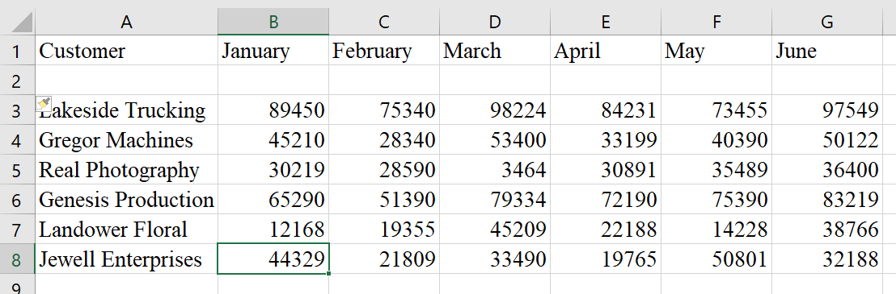

Formatting
- Format Columns B3-K8 in currency with 2 decimals
- Format I2 to K2 to percentage with zero decimals
- Insert the following text:
  - H1: 6 Month Sales
  - I1: Consultant Fee
  - J1: Federal Tax
  - K1: State Tax
  - I2: 10
  - J2: 17
  - K2: 11
- Create a copy of Period 1 Sales spreadsheet and rename worksheet 2 as Period 2 sales

Formulas
- Create the following formulas for Period 1 Sales
  - H3 a function that totals the 6 month sales for the company. Fill down.
  - I3 an absolute formula that calculates the consultant fee each company pays. Fill down.
  - J3 an absolute formula that calculates the federal tax each company pays. Fill down.
  - K3 an absolute formula that calculates the state tax each company pays. Fill down.
- Create the following formulas for Period 2 Sales
  - H3 a function that totals the 6 month sales for the company. Fill down.
  - I3 an absolute formula that calculates the consultant fee each company pays. Fill down.
  - J3 an absolute formula that calculates the federal tax each company pays. Fill down.
  - K3 an absolute formula that calculates the state tax each company pays. Fill down.

Enter the data into a new worksheet: Name the worksheet: Summary

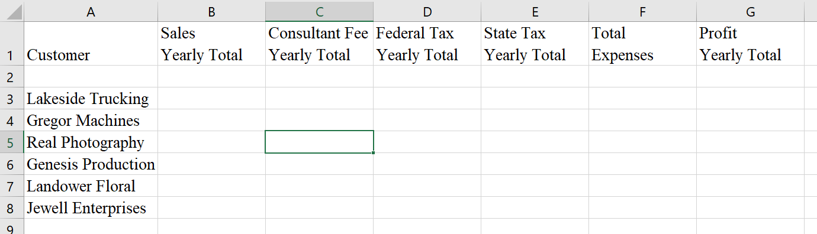v

Formatting
- Format Columns B3-G8 in currency with 2 decimals
- Bold row 1.
- Format B1 to G1 with fill style 40% accent 6.
- Fill rows 4, 6, and 8 with custom color:
  - Red 217
  - Green 225
  - Blue 242
- Format B1 to G1 with a think bottom border
- Place left/right border for columns B2 through G8
- Delete Row 2

Formulas
- On the Summary Sheet use a 3-D reference to total the sales in cells B3:B8 for both sales periods.
- On the Summary Sheet use a 3-D reference to total the consultant fees in cells C3:C8 for both sales periods.
- On the Summary Sheet use a 3-D reference to total the federal tax in cells C3:C8 for both sales periods.
- On the Summary Sheet use a 3-D reference to total the state tax in cells C3:C8 for both sales periods.
- On the Summary Sheet total the expenses.
- On the Summary Sheet compute the profit for each company.
- Best fit all the columns

Pivot Chart
- Create a PivotTable and Chat on a new worksheet using data from the summary worksheet.
- Name the worksheet: Pivot Information
- Use the fields:
  - Customer in columns
  - Sum of Profit in Values
- Fill Chart in cells B7 to G26.
- Format chart in layout 10
- Format the PivotTable data to Currency with 2 decimal places.

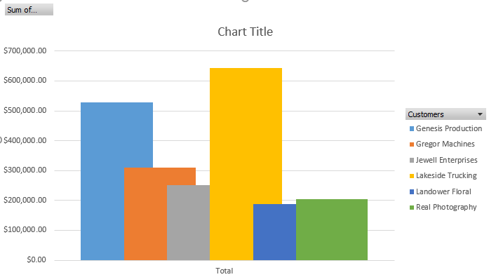

Macro
On the summary worksheet in cell A11
Create a macro named CompanyInfo and use the shortcut key CTRL+ Shift + Q to execute the macro.
- Record a macro named CompanyInfo that will allow you to hit CTRL+ Shift + Q to set the text.
  - Make sure the “store macro in” box displays this workbook.
  - Use the description “Company name and address”
  - Create the macro to print the name of the company and address.
    - Blue Scape Consulting
    - 11032 Robinson Drive
    - Nashville, TN 37011
    - 1-800-651-9923
  - Format parent company name only to 18 points, Blue font color
  - Format a thick box border around the company name and address
  - Format a fill with custom color:
    - Red: 198
    - Green: 224
    - Blue: 180
- Execute the macro on the Period 1 and 2 Sales worksheets in cell A11 using the shortcut key.

Print the following worksheets; adjust printout footer numbers as needed

Printout 1
- Summary worksheet in landscape orientation, centered vertically and horizontally. Your report should fit on one page with no truncated data.

Printouts 2 & 3
- Show formulas from Summary and Period Sales 1 worksheets.
- Print out the page, landscape orientation, centered vertically and horizontally. Each worksheet report should fit on one page each with no truncated data.

Printouts 4 & 5
- Print both the Period 1 Sales and Period 2 Sales worksheets, landscape orientation, centered vertically and horizontally. Your report should fit on one page with no truncated data.

Printout 6
- Print the Pivot Chart worksheet landscape orientation on one page vertically and horizontally centered.

Printout 7
- Print a copy of the visual basic of the data macro.

